# KPI

## 1. Sales

-- 1. Sales

SELECT

SUM(Unit_Price*Sales_Volume) AS 'Sales'

FROM Forte_Grocery

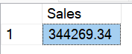

## 2. Profit

-- 2. Profit

SELECT

SUM(((Unit_Price * 0.4) * Sales_Volume)) AS 'Profit'

FROM Forte_Grocery

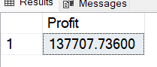

## 3. Total Sales Volume

-- 3. Total Sales Volume

SELECT SUM(Sales_Volume) AS Total_Sales_Volume

FROM Forte_Grocery

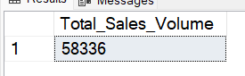

## 4. Inventory Value

-- 4. Inventory Value

SELECT

CAST(SUM((Unit_Price*0.6)*Stock_Quantity) AS DECIMAL (10,2)) AS 'Inventory Value'

FROM Forte_Grocery;

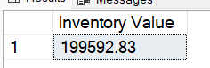

## 5. Inventory Units

--5. Inventory Units

SELECT

SUM(Stock_Quantity) AS 'Inventory Unit(s)'

FROM Forte_Grocery

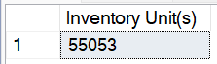

## 6. No. of Suppliers

-- 6. No. of Suppliers

SELECT

COUNT(DISTINCT Supplier_Name) AS 'Total Suppliers'

FROM Forte_Grocery

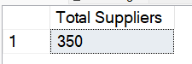

## 7. To get the Total Current Reorder Cost

-- 7. To get the Total Current Reorder Cost

WITH ReorderDetail AS (

SELECT

Product_Name,

Reorder_Quantity,

CAST(SUM((Unit_Price*0.6)*Reorder_Quantity) AS DECIMAL (10,2)) AS Reorder_Cost_Each_Product,

Supplier_Name

FROM Forte_Grocery

WHERE Stock_Quantity < Reorder_Level AND Status <> 'Discontinued'

GROUP BY Product_Name, Reorder_Quantity, Supplier_Name

)

SELECT

SUM(Reorder_Cost_Each_Product) AS 'Total Reorder Cost'

FROM ReorderDetail

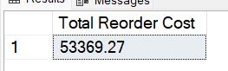

## 8. Number of Products to Reorder

-- 8. Number of Products to Reorder

WITH ReorderDetail AS (

SELECT

Product_Name,

Reorder_Quantity,

CAST(SUM(Unit_Price*Reorder_Quantity) AS DECIMAL (10,2)) AS Reorder_Cost_Each_Product,

Supplier_Name

FROM Forte_Grocery

WHERE Stock_Quantity < Reorder_Level AND Status <> 'Discontinued'

GROUP BY Product_Name, Reorder_Quantity, Supplier_Name

)

SELECT

COUNT (Product_Name) AS Number_of_Products_to_Reorder

FROM ReorderDetail

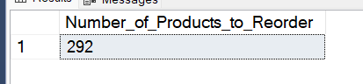

## 9. Total Stock Quantity vs Total Reorder Level

-- 9. Total Stock Quantity vs Total Reorder Level

SELECT

SUM(Stock_Quantity) AS Total_Stock_Quantity,

SUM(Reorder_Level) AS Total_Reorder_Level

FROM Forte_Grocery

WHERE Stock_Quantity < Reorder_Level AND Status <> 'Discontinued';

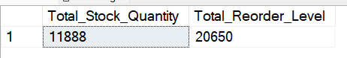

## 10. Average Delivery Time (Days) for All Suppliers

-- 10. Average Delivery Time (Days) for All Suppliers

WITH DeliveryData AS (

SELECT

Supplier_Name,

SUM(Reorder_Quantity) AS Total_Orders,

ROUND(AVG(CASE

WHEN Date_Received >= Last_Order_Date THEN DATEDIFF(DAY, Last_Order_Date, Date_Received)

ELSE NULL

END), 2) AS Avg_Delivery_Time_Days

FROM Forte_Grocery

WHERE Last_Order_Date IS NOT NULL

AND Date_Received IS NOT NULL

AND Date_Received >= Last_Order_Date

GROUP BY Supplier_Name

)

SELECT

AVG(Avg_Delivery_Time_Days) AS Avg_Delivery_Time_All_Suppliers

FROM DeliveryData;

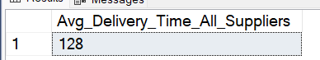

# CHART

## Fixing Error (Correct Header Spelling and Replace Null Value)

**In order to get the Profit Estimation by Category, I just realised there are some errors in the data and it needed to be fixed.**

1. I found out a column header is misspelled as ‘Catagory’ instead of ‘Category’

--Renaming column ‘Catagory’ to ‘Category’

sp_rename 'Forte_Grocery.Catagory', 'Category', 'COLUMN';

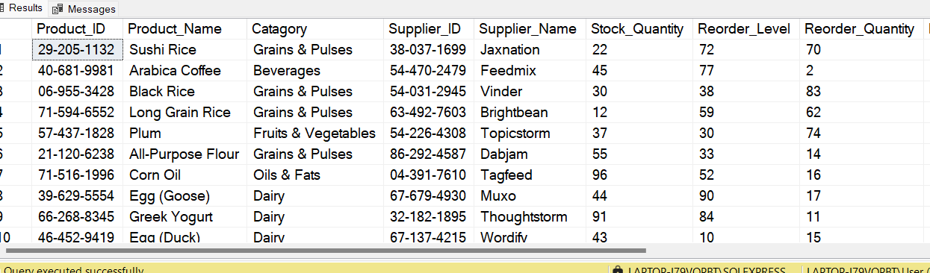

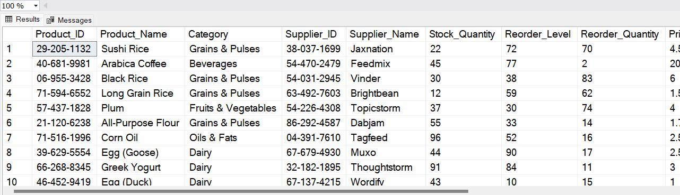

2. I found out that there is a NULL value in a cell under the ‘Category’ column. The ‘Product_Name’ is ‘Cabbage’ so the NULL value should be ‘Fruits & Vegetables.

--When quering for then average price per category, I found a NULL value under category.

SELECT

Category,

ROUND(AVG(Unit_Price),2) AS 'Average Price'

FROM Forte_Grocery

GROUP BY Category

ORDER BY 'Average Price' DESC;

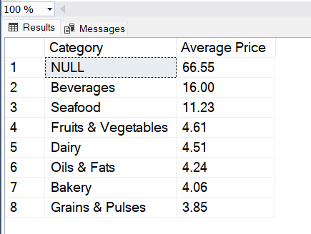

--Finding which cell under the category column is null, with its corresponding product name.

SELECT

Product_Name,

Category

FROM Forte_Grocery

WHERE Category IS NULL;

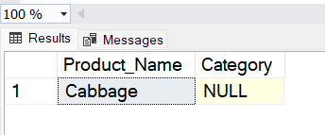

--Replacing a Null Value in Category to ‘Fruits & Vegetables

Update Forte_Grocery

SET Category = 'Fruits and Vegetables'

WHERE Category IS NULL

## 1. Estimated Profit by Category

-- 1. Estimated Profit by Category

SELECT

Category,

CAST(SUM((Unit_Price - (Unit_Price * 0.6))*Sales_Volume) AS DECIMAL (10,2)) AS Estimated_Profit_by_Category

FROM Forte_Grocery

GROUP BY Category

ORDER BY Estimated_Profit_by_Category DESC;

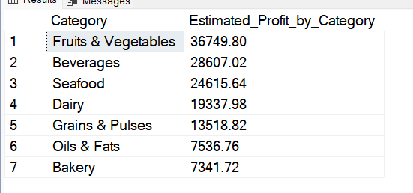

## 2. Percentage of Estimated Profit by Category

-- 2. Percentage of Profit Estimation by Category

WITH ProfitData AS (

SELECT

Category,

SUM((Unit_Price - (Unit_Price*0.6))*Sales_Volume) AS Estimated_Profit_by_Category

FROM Forte_Grocery

GROUP BY Category

)

SELECT

Category,

CAST((Estimated_Profit_by_Category / (SELECT SUM(Estimated_Profit_by_Category) FROM ProfitData))*100 AS DECIMAL (10,2)) AS Percentage_of_Estimated_Profit_by_Category

FROM ProfitData

ORDER BY Percentage_of_Estimated_Profit_by_Category DESC;

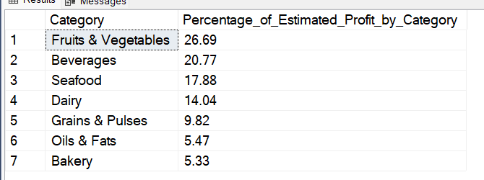

## 3. Sales Volume by Category

-- 3. Sales Volume by Category

SELECT

Category,

SUM(Sales_Volume) AS Sales_Volume_by_Category

FROM Forte_Grocery

GROUP BY Category

ORDER BY Sales_Volume_By_Category DESC;

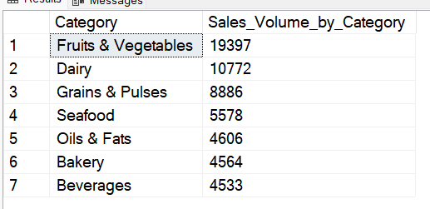

## 4. Percentage of Sales Volume by Category

-- 4. Percentage of Sales Volume by Category

WITH SalesData AS(

SELECT

Category,

SUM(Sales_Volume) AS Sales_Volume_by_Category

FROM Forte_Grocery

GROUP BY Category

)

SELECT

Category,

CAST((Sales_Volume_by_Category/cast((SELECT SUM(Sales_Volume_by_Category) FROM SalesData) AS DECIMAL (10,2)))*100 AS DECIMAl (10,2)) AS Percentage_of_Sales_Volume_by_Category

FROM SalesData

ORDER BY Percentage_of_Sales_Volume_by_Category DESC;

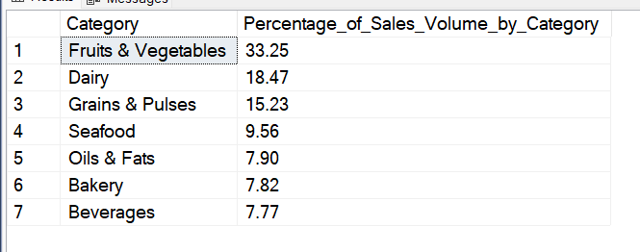

## 5. Average Price per Category

-- 5. Average Price per Category

SELECT

Category,

ROUND(AVG(Unit_Price), 2) AS Average_Price

FROM Forte_Grocery

GROUP BY Category

ORDER BY Average_Price DESC;

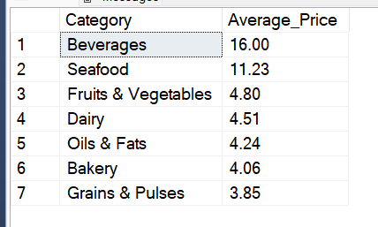

## 6. Top 20 Profitable Products

-- 6. Top 20 Profitable Products

SELECT

TOP 20 Product_Name,

Category,

CAST(SUM((Unit_Price - (Unit_Price * 0.6))*Sales_Volume) AS DECIMAL (10,2)) AS Profit_per_Product,

Unit_Price

FROM Forte_Grocery

GROUP BY Product_Name, Category, Unit_Price

ORDER BY Profit_per_Product DESC;

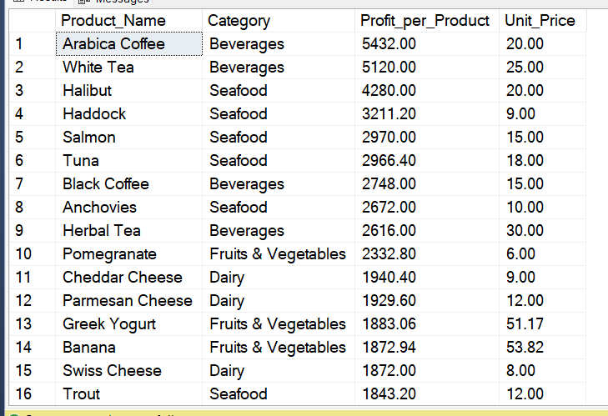

## 7. Top 20 Selling Products (Highest Sale Volume)

-- 7. Top 20 Selling Products (Highest Sale Volume)

SELECT

TOP 20 Product_Name,

Category,

SUM(Sales_Volume) AS Total_Sales,

Unit_Price

FROM Forte_Grocery

GROUP BY Product_Name, Category, Unit_Price

ORDER BY Total_Sales DESC;

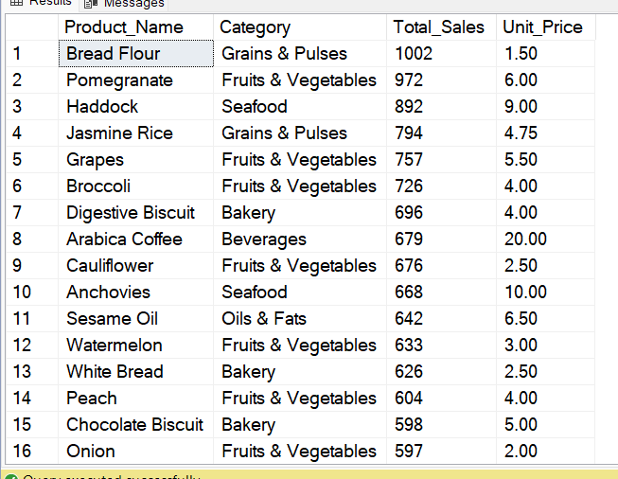

## 8. Stock Levels & Reorder Alerts

-- 8. Stock Levels & Reorder Alerts (Products Needing Replenishment)

SELECT

Product_Name,

Stock_Quantity,

Reorder_Level,

CASE WHEN Stock_Quantity <= Reorder_Level THEN 'Reorder Needed' ELSE 'Sufficient Stock' END AS Status

FROM Forte_Grocery

ORDER BY Stock_Quantity ASC;

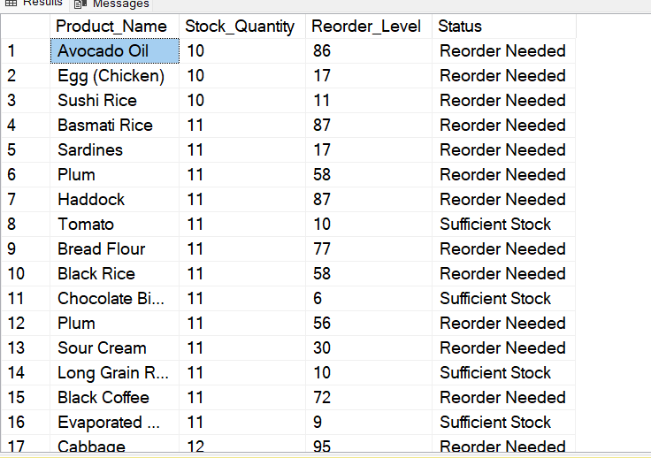

## 9. Reorder Quantity and Reorder Cost for Each Product

-- 9. Reorder Quantity and Reorder Cost for Each Product

SELECT

Product_Name,

Reorder_Quantity,

CAST(SUM((Unit_Price*0.6)*Reorder_Quantity) AS DECIMAL (10,2)) AS Reorder_Cost_Each_Product,

Supplier_Name

FROM Forte_Grocery

WHERE Stock_Quantity < Reorder_Level AND Status <> 'Discontinued'

GROUP BY Product_Name, Reorder_Quantity, Supplier_Name

ORDER BY Reorder_Cost_Each_Product DESC;

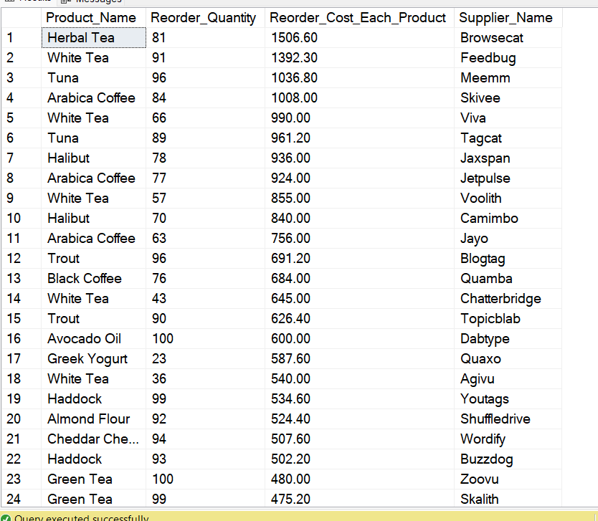

--To get the Total Current Reorder Cost

WITH ReorderDetail AS (

SELECT

Product_Name,

Reorder_Quantity,

CAST(SUM((Unit_Price*0.6)*Reorder_Quantity) AS DECIMAL (10,2)) AS Reorder_Cost_Each_Product,

Supplier_Name

FROM Forte_Grocery

WHERE Stock_Quantity < Reorder_Level AND Status <> 'Discontinued'

GROUP BY Product_Name, Reorder_Quantity, Supplier_Name

)

SELECT

SUM(Reorder_Cost_Each_Product) AS 'Total Reorder Cost'

FROM ReorderDetail

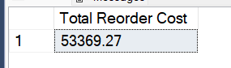

## 10. Total Stock Quantity, Total Reorder Level, Total Reorder Quantity, Estimated Stock After

-- 10. Total Stock Quantity, Total Reorder Level, Total Reorder Quantity, Estimated Stock After Reorder

SELECT

SUM(Stock_Quantity) AS Total_Stock_Quantity,

SUM(Reorder_Level) AS Total_Reorder_Level,

SUM(Reorder_Quantity) AS Total_Reorder_Quantity,

(SUM(Stock_Quantity) + SUM(Reorder_Quantity)) AS Estimated_Stock_After_Reorder

FROM Forte_Grocery

WHERE Stock_Quantity < Reorder_Level AND Status <> 'Discontinued';



## 11. Average Delivery Time (Days) by Supplier

-- 11. Average Delivery Time (Days) by Supplier

SELECT

Supplier_Name,

SUM(Reorder_Quantity) AS Total_Orders,

ROUND(AVG(CASE

WHEN Date_Received >= Last_Order_Date THEN DATEDIFF(DAY, Last_Order_Date, Date_Received)

ELSE NULL

END), 2) AS Avg_Delivery_Time_Days

FROM Forte_Grocery

WHERE Last_Order_Date IS NOT NULL

AND Date_Received IS NOT NULL

AND Date_Received >= Last_Order_Date

GROUP BY Supplier_Name

ORDER BY Avg_Delivery_Time_Days ASC;

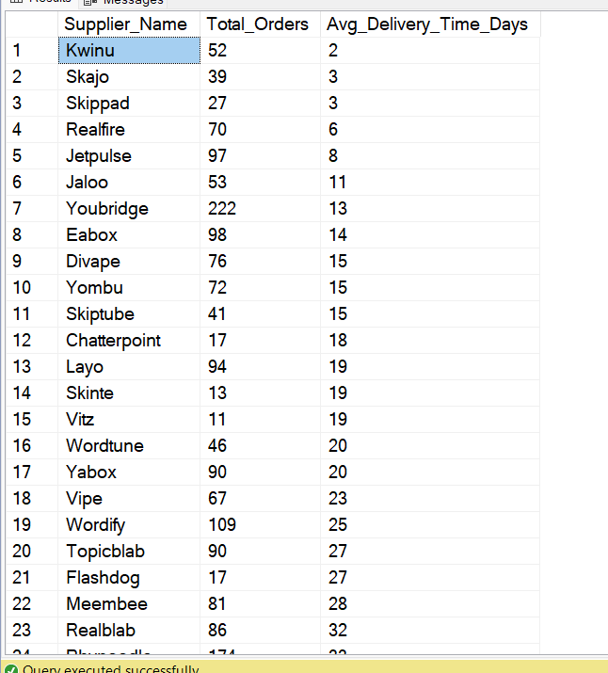

## 12. Average Delivery Time (Days) and Unit Cost for Particular Product by Supplier

-- 12. Average Delivery Time (Days) and Unit Cost for Particular Product by Supplier

SELECT

Product_Name,

Supplier_Name,

CAST((Unit_Price*0.6) AS DECIMAL(10,2)) AS Unit_Cost,

ROUND(AVG(DATEDIFF(DAY, Last_Order_Date, Date_Received)), 2) AS Avg_Delivery_Time_Days,

SUM(Reorder_Quantity) AS Total_Orders

FROM Forte_Grocery

WHERE Last_Order_Date IS NOT NULL

AND Date_Received IS NOT NULL

AND Date_Received >= Last_Order_Date

GROUP BY Product_Name, Supplier_Name, Unit_Price

ORDER BY Product_Name, Avg_Delivery_Time_Days ASC;

# DAX FUNCTION

## Total Sales

Total Sales = SUMX (Forte_Grocery, Forte_Grocery[Unit_Price]*Forte_Grocery[Sales_Volume])

## Total Profit

Total Profit = SUMX (Forte_Grocery, (Forte_Grocery[Unit_Price]*0.4)*Forte_Grocery[Sales_Volume])

## Total Reorder

Total Reorders =

CALCULATE(

SUM('Forte_Grocery'[Reorder_Quantity]),

FILTER(

'Forte_Grocery',

NOT(ISBLANK('Forte_Grocery'[Last_Order_Date])) &&

NOT(ISBLANK('Forte_Grocery'[Date_Received])) &&

'Forte_Grocery'[Date_Received] >= 'Forte_Grocery'[Last_Order_Date]

)

)

## Total Reorder Cost

Total Reorder Cost =

CALCULATE(

SUMX(

'Forte_Grocery',

('Forte_Grocery'[Unit_Price] * 0.6) * 'Forte_Grocery'[Reorder_Quantity]

),

'Forte_Grocery'[Stock_Quantity] < 'Forte_Grocery'[Reorder_Level],

'Forte_Grocery'[Status] <> "Discontinued"

)

## Number of Product to Reorder

Number of Products to Reorder =

CALCULATE(

DISTINCTCOUNT('Forte_Grocery'[Product_Name]),

'Forte_Grocery'[Stock_Quantity] < 'Forte_Grocery'[Reorder_Level],

'Forte_Grocery'[Status] <> "Discontinued"

)

## Inventory Value

Inventory Value = SUMX(Forte_Grocery, (Forte_Grocery[Unit_Price]*0.6)*Forte_Grocery[Stock_Quantity])

## Average Delivery Time (Days)

Avg Delivery Time (Days) =

VAR AvgDays =

CALCULATE(

AVERAGEX(

FILTER(

'Forte_Grocery',

'Forte_Grocery'[Date_Received] >= 'Forte_Grocery'[Last_Order_Date]

),

DATEDIFF('Forte_Grocery'[Last_Order_Date], 'Forte_Grocery'[Date_Received], DAY)

)

)

RETURN IF(ISBLANK(AvgDays), 0, AvgDays)

## Delivery Days

Delivery_Days =

IF(

'Forte_Grocery'[Date_Received] >= 'Forte_Grocery'[Last_Order_Date],

DATEDIFF('Forte_Grocery'[Last_Order_Date], 'Forte_Grocery'[Date_Received], DAY),

BLANK())

## Search Filter

SearchFilter =

'Forte_Grocery'[Product_Name] & " " &

'Forte_Grocery'[Supplier_Name] & " " &

'Forte_Grocery'[Status]

## Stock Level Alert

Stock Level Alert =

IF(

Forte_Grocery[Stock_Quantity]<Forte_Grocery[Reorder_Level],

"Reorder Needed",

"Sufficient Stock"

)